Title Page

**Sentinel behaviour and urban environments: A corvid’s perspective**

By

Alex Popescu. B.Sc.

Biological Sciences (Ecology & Evolution)

A thesis

submitted in partial fulfillment

of the requirements for the degree of

Master of Science

Faculty of Mathematics and Sciences,

Brock University

St. Catharines, Ontario, Canada

© 2023

Abstract

Acknowledgements

I’d like to thank Dr. Kiyoko Gotanda for taking me on as a graduate student in the middle of the 2021 pandemic. I would not be where I am without the opportunities, advice, support, and patience you have given me. You have helped me conquer many challenges and pushed me to learn new skills. I cannot thank you enough.

Next. I would like to thank my other committee members Dr. Liette Vasseur and Dr. Anne Clark for their wealth of knowledge and the guidance they have given me throughout my thesis.

My fellow lab-members Alex Wilder and Albert Wu were sources of new perspectives and great improvements. Alex, I can’t thank you enough for those awful 6AM drives for a whole summer. I can’t begin to describe how priceless your help was. Albert, you have been instrumental in keeping myself productive and accountable. You have both been instrumental during my time at Brock University.

My family and friends have always been at my side, through thick and thin. From helping me move to St. Catharines, to being someone I could vent to, they have always been there for me. They listened in times of doubt and celebrated with me my accomplishments. My parents’ continued desire to see me improve are the reason I undertook this monumental task, and I would like to thank them for helping me achieve my full potential.

Lily, you came to St. Catharines with me, jumping head-first with me into completely new experiences, responsibilities, and a surprising amount of dishes. We have lived through so much, and I can’t see myself living without you. Thank you so much for your incredible support and for keeping me going in during the harder times.

Table of Contents

Title Page I

Abstract II

Acknowledgements III

Table of Contents IV

List of Tables VI

List of Figures VII

General Introduction 1

Sentinel Behaviour 1

Urbanization 4

The American crow, Corvus brachyrhynchos 6

Research Objectives 7

Chapter 1: Sentinel behaviour in mammal and avian species 9

Introduction 9

Methods 10

Selection criteria 10

Search strategy 10

Data collection & analysis 12

Results 14

Trends observed 15

Discussion 18

Chapter 2: Heads up! Social vigilance behaviour in urban American crows 18

Introduction 18

Sentinel Behaviour 19

Urban Environments 20

Study Objectives 21

Significance 22

Methods 24

Site Selection 24

Field observation 24

Video Analysis 27

Statistical Analysis 27

Results 29

Sentinel presence 29

Proportion of time allocated to each behaviour 29

Duration of bouts of all behaviours 32

Duration of bouts of “foraging” behaviour 32

Duration of bouts of “alert” behaviour 35

Foraging rate 38

Transition analysis 38

Discussion 46

Sentinel behaviour 46

Generalized Environment 48

Disturbances 50

Baited sites 51

Group Size 51

Future directions and improvements 52

Conclusion 52

General Discussion 54

References 55

Supplemental Material 62

List of Supplemental Tables 62

List of Supplemental Figures 62

List of Tables

Table 1: Inclusion and exclusion criteria for scoping review 11

Table 2: Search string used on Nov. 1st, 2022 13

Table 3: Number of articles retained by the search strategy 16

Table 4: Effects of sentinel presence and generalized environment on the proportion of time allocated to each behaviour 31

Table 5: Results of the linear mixed models fit to the mean bout duration 34

Table 6: Result of the linear mixed model fit to peck rate 40

Table 7: Results of generalized linear mixed model fit to the number of transitions performed by foragers 43

List of Figures

Figure 1: ROSES Flow diagram showing literature sources and inclusion/exclusion process. 15

Figure 2: Map of observations from Crowkemon Go and sampling locations. 25

Figure 3: Proportion of time allocated to each behaviour by foragers in commercial and green areas 30

Figure 4: Mean bout duration of foragers in commercial and green areas. 33

Figure 5: Mean foraging bout duration of crows in small and large groups. 36

Figure 6: Foraging bout duration decreasing with increasing disturbance frequency. 37

Figure 7: Mean peck rate of foragers in commercial and green areas. 39

Figure 8: Peck rate in relation to disturbance frequency. 41

Figure 9: Number of transitions performed by foragers in commercial and green areas. 42

Figure 10: The number of transitions from foraging to alert behaviour decreases as disturbance frequency increases. 44

General Introduction

Sentinel Behaviour

The original definition for sentinel behaviour in animals likely originates from the human definition of a sentinel where a guard keeps watch over other group-members, alerting them of potential dangers or threats. Similarly, animal sentinels take on the role of a sentinel by exhibiting constant vigilance over other group-members from a prominent, exposed position and making alarm calls when sources of danger are detected [1,2]. Observations of sentinel behaviour have very likely been made by naturalists and researchers for centuries and the earliest descriptions of sentinel behaviour in animals appear in mid-20th century research articles, mostly associated with the behaviour of birds and mammals. Sentinel behaviour has been predominantly researched in avian species, though much research has been done on the behaviour in mammal and even in aquatic species. Possibly the most recognizable sentinel species are meerkats, *Suricata suricatta,* a species whose sentinels stand up on their hind legs to perform sentinel duties [3–8]. Studies have also been conducted on sentinel behaviour in certain mongoose and primate species [9–14]. In avian species, sentinel systems have been described and exhaustively researched in species of the *Aphelocoma* [15–19], *Argya* [20–25], and *Turdoides* genera [26,27]. Since this behaviour is not limited to those genera and is shared across several taxa without common ancestry, this behaviour must have evolved when very specific environmental and social conditions were met [28,29].

Sentinel behaviour is an effective strategy to help balance a fundamental trade-off between foraging and vigilance [30]. These two behaviours are generally considered mutually exclusive and are equally important [31,32]. Time spent performing each behaviour must be carefully managed [32,33]. A reduction of vigilance to increase foraging efficiency can result in increased risk of predation. A sentinel’s vigilance can compensate for the individual decrease in vigilance, providing an advantage to species that exhibit this behaviour.

Yet, the underlying mechanisms for sentinel decision-making are not clear, giving rise to much debate over whether this behaviour is a selfless or selfish behaviour. The former hypothesis is that sentinel behaviour is selfless, where individuals take turns provide benefits to other group members at their expense. Whether through reciprocal altruism [34] or kin selection [35], the behaviour is self-sacrificing and primarily benefits the group. This could be due to direct benefits including increased foraging efficiency and reduced predation risk. The latter hypothesis is that sentinel behaviour could be driven by selfish, state-dependent decisions. Originally hypothesized by P.A. Bednekoff, an important contributor to research on sentinel behaviour, this state-dependent model for sentinel decision-making revolves around an individual’s energetic reserves and requirements [28,29]. Individuals who have sufficient energetic reserves are more inclined to perform sentinel duties if the alternative is foraging without a sentinel, a considerably more dangerous option than being sentinel. Studies on the effects of satiation and body mass on the propensity of an individual to perform sentinel behaviour support this hypothesis [3,25,30,36]. These two hypotheses are not mutually exclusive, and sentinel behaviour invariably provides benefits to other individuals in the group and could benefit the sentinel itself. Studies support this showing that dominant males will perform more sentinel behaviour when in the presence of auditory or chemical signals from out-group rivals [37,38]. Dominant males could be using sentinel behaviour to also gather information about rival groups and defend against intrusion. Sentinel behaviour could then serve additional purposes apart from the identification of possible threats.

Individuals under the watchful eye of a sentinel receive significant benefits. Other group-members could reduce their individual vigilance and increase their foraging efficiency as vigilance is ensured by the sentinel [39]. A sentinel cannot be vigilant in perpetuity, and eventually will relinquish the position to perform other behaviours. The coordination of sentinels is therefore crucial to minimize the gaps in coverage and ensure the safety of the group [1,28,29]. The coordination of sentinels has been recognized as the defining feature of sentinel behaviour since adopting an exposed position and making alarm calls are not behaviours exclusive to sentinel behaviour [1,19,28]. This definition is not universally used, resulting in possible misidentification of sentinel behaviour in non-sentinel species.

Urbanization

Unfortunately, these specialist species are at a severe disadvantage in the face of urbanization [40,41]. Urbanization is the shift in the human population towards urban centers, resulting in ever-expanding urban areas and the modification of wide swathes of wildlands. With over 55% of the global human population living in urban areas and a forecasted increase in this percentage in the following decades [42], wildlife will increasingly be affected by the environmental changes made to accommodate human occupation. Species must therefore quickly adapt to minimize fitness losses accrued by foraging in unnatural, anthropogenic environments.

Specialist species are at a disadvantage when compared to more generalist species if the conditions to which they are adapted to are no longer present. Since urbanization can cause habitat loss or fragmentation, and increases the frequency and severity of anthropogenic disturbances [43,44], specialist species are often ill-suited for urban spaces, resulting in species extirpation and even extinction. This can be observed in the significant loss of biodiversity caused by the ever-increasing global urbanization [45].

Generalist species are better suited to forage in most conditions than specialist species and could even benefit from living and foraging in urban areas [40,41]. Such species could adapt at many levels, with physiological, morphological, and behavioural adaptations being observed in many species [43,44,46,47]. Behavioural adaptations such as the use of anthropogenic structures for nesting, changes in foraging such as preferentially consuming anthropogenic foods and vigilance such as increased tolerance to human proximity and disturbances are some of many adaptations observed in urbanized species. As a result, urbanized species could increase in abundance in urban areas [48]. The abundance of American crows (*Corvus* brachyrhynchos) has been consistently increasing over the years, correlating with the increase in the size and number of urban areas and cities [49–52]. Adaptations to urban living have also been observed in these species, such as preferring anthropogenic foods and greatly increased tolerance to human proximity [49,51–54].

Urban living can also have effects on a species’ social behaviours. For example, urban areas can reduce the effectiveness of sentinel behaviour because of increased anthropogenic noise which make sentinel calls and signals more difficult to hear [9,55]. In such scenarios, species increased their individual vigilance despite the presence of a sentinel [55]. Urban areas also have an increased abundance and predictability of food sources (e.g. litter, trash cans, dumpsters) containing highly caloric anthropogenic foods. Individuals could therefore consume more energy in a quicker manner than in wilder, less disturbed areas, resulting in greater body mass and energetic reserves [56,57]. If Bednekoff’s model of state-dependent decision-making holds true, individuals should then be able to perform sentinel behaviour earlier, more often and/or for longer [28,29]. Considering that sentinel behaviour can provide advantages to both antipredator vigilance and foraging efficiency, sentinel species could be better suited to foraging in urban areas, outcompeting non-social and less adapted individuals.

The American crow, Corvus brachyrhynchos

American crows are a cooperatively breeding species that can be found in most North American cities [49,50]. Sentinels are often spotted in the proximity of groups of foraging crows, and a sentinel system has been described in the species [58]. Their synurbic and social nature therefore makes them good models to determine if the use of social behaviours, specifically sentinel behaviour, is adaptive in urban areas. By observing the behaviour of foraging American crows, we could make inferences about how the use of sentinel behaviour is impacted by the foraging environment, and by extension, urbanization. Their use of sentinel behaviour could allow them to forage more effectively and safely than other species, possibly contributing to their success in urban environments. The increasing abundance of American crows and other urban sentinel species could be contributing to the loss of biodiversity in and around urban areas, exacerbating an already devastating problem.

Research Objectives

In chapter 1, we performed a scoping review on the currently available literature on intrinsic and extrinsic factors affecting sentinel decision-making in terrestrial and avian species. We discuss the trends observed in studies on these factors and explore how urbanization could alter an individual’s decision to perform this behaviour. The purpose of this chapter is to help predict and explain the results of the chapter 2’s observational study. we hypothesized that sentinel behaviour can be affected by both intrinsic and extrinsic factors, and that while some factors are unchangeable, many can be affected by urbanization.

In chapter 2, we investigate the results of an observational study we undertook in summer 2022. The objective was to determine how American crows alter their use of sentinel coverage when foraging in different urban areas. To do this, we recorded foraging crows and measured the duration of bouts of alert and foraging behaviours. Since these two behaviours are mutually exclusive and directly linked with Lima’s theory of a foraging-vigilance trade-off [32], they are good metrics to measure how the foragers perceive their environment and use the added vigilance provided by the sentinel. We hypothesize that foragers will reduce the time spent being vigilant in green areas and in the presence of a sentinel, as the sentinel’s vigilance will be more effective due to increased lines of sight and decreased ambient noise levels.

Chapter 1 of this thesis will provide some insights into how intrinsic and extrinsic factors could affect sentinel behaviour in mammal and avian species. By identifying the main factors involved in sentinel decision-making, we can infer how urbanization could affect the decision to perform the behaviour. Moreover, the results of chapter 2 will help elucidate how foragers respond to the presence of a sentinel and its foraging environment. These results of this thesis could help explain why certain social species, including the American crow, are so successful in urban areas and how sentinel behaviour could contribute to this success.

Chapter 1: Sentinel behaviour in mammal and avian species

Introduction

Methods

This scoping review followed the ROSES standards of reporting for scoping and systematic reviews to the best of our ability [59]. The protocol was not pre-published, though our objective was to ensure transparency and maximize the reproducibility of the search performed.

Selection criteria

The inclusion and exclusion criteria for the screening were identified and noted before initiating database searches (Table 1). We searched various databases for studies on the effects of a factor on a quantitative measurement of sentinel behaviour (e.g., frequency, duration, number of bouts, etc.). We only included articles that tested sentinel behaviour in terrestrial or avian vertebrates. Aquatic species can have different methods of identifying threats and communicating their presence. We excluded articles published before 1970, because the definition of sentinel behaviour prior to this date was nebulous and not consistent with the currently used definition of sentinel behaviour. For inclusion, we defined sentinel behaviour as an individual that adopts a prominent, exposed position and whose purpose is to maintain constant vigilance over other group members, whether coordinated or not [1,2]. Theoretical or review articles were excluded, though review article citations were screened. We also excluded mixed-species flocks to better observe effects on sentinel behaviour within a species, without the effects of eavesdropping and fake alarm cries performed by other species [60].

Search strategy

On Jan. 24th, 2022, a preliminary search was performed in Web of Science and Google Scholar to find relevant articles and generate a list of exemplar articles using “sentinel behaviour in animals” as a search string. This list of 20 articles was subsequently used to test the

Table 1: Inclusion and exclusion criteria for scoping review

|  |  |
| --- | --- |
| **Inclusion Criteria** | **Description** |
| Study design | Study must be experimental; testing the effect of one or more factors on some element of sentinel behaviour. |
| Model species | Model species must be terrestrial or avian, and vertebrate. |
| Date of publication | Article must be published after 1970. |
| Major concepts | Must be related to behaviour, behavioural ecology or adjacent and related fields. |
|  |  |
| **Exclusion Criteria** | **Description** |
| Study design | Study must not be observational (e.g. X species has a sentinel system), or mathematical/theoretical. |
| Model species | Model species must not be aquatic and must not be invertebrate. |
| Date of publication | Article must not be published before 1970. |
| Major concepts | Exclude studies from non-behaviour related fields (e.g. remote sensing, sentinels of ecosystem health/biodiversity, sleep). |

comprehensiveness of the final search strategy and screening. Common keywords in the exemplar articles were compiled and used to develop the search string. The final search string we used to search for articles was "Sentinel AND Behavio*" (Table 2). We filtered the articles by removing articles in fields unrelated to behaviour (e.g., sleep, remote sensing). On Nov. 1st, 2022, we searched through Web of Science Complete, which included Web of Science Core, Current Contents Connect, Zoological Records, SciELO Citation Index, KCI-Korean Journal Database, BIOSIS Citation Index, Data Citation Index, and exported the list of search results. Using the factors identified during the full-text screening of articles, ELICIT was used to search for any articles not present in the databases searched on Nov. 20th,2023 using variations of the search string “how does [factor] affect sentinel behaviour?” [61].

Data collection & analysis

Title and abstract were screened three times using the "Metagear" package in R (v.4.2.3, [62]) by following the inclusion and exclusion criteria (Table 1). Full texts of articles were then screened for inclusion or exclusion based on our criteria. How changes in sentinel behaviour were measured (e.g. total duration, length of bout) and which factors tested by the articles were recorded, as well as the species of interest. We later grouped the factors as either intrinsic (e.g. sex, age, body mass) or extrinsic (e.g. anthropogenic noise, presence of predators or outgroup rivals). We also kept a record of articles that defined sentinel behaviour, and if that definition included coordination as a defining feature as proposed by Bednekoff [1].

Table 2: Search string used on Nov. 1st, 2022

|  |  |
| --- | --- |
| **Element** | **String** |
| Topic | sentinel AND Behavio* |
| Language | “ENGLISH” |
| Subject | “BEHAVIORAL SCIENCES” |
| NOT Subject | "HEALTH CARE SCIENCES SERVICES" OR "PEDIATRICS" OR "PHARMACOLOGY PHARMACY" OR "MARINE FRESHWATER BIOLOGY" OR "GENERAL INTERNAL MEDICINE" OR "METEOROLOGY ATMOSPHERIC SCIENCES" OR "SUBSTANCE ABUSE" OR "CRIMINOLOGY PENOLOGY" OR "RADIOLOGY NUCLEAR MEDICINE MEDICAL IMAGING" OR "SURGERY" OR "MEDICAL LABORATORY TECHNOLOGY" OR "PUBLIC ENVIRONMENTAL OCCUPATIONAL HEALTH" OR "WOMEN APOS S STUDIES" OR "GEOCHEMISTRY GEOPHYSICS" OR "RESEARCH EXPERIMENTAL MEDICINE" OR "IMAGING SCIENCE PHOTOGRAPHIC TECHNOLOGY" OR "EDUCATION EDUCATIONAL RESEARCH" OR "BUSINESS ECONOMICS" OR "BIOTECHNOLOGY APPLIED MICROBIOLOGY" |

Results

Our search string collected 364 articles on Web of Science. Title and abstract screening rejected 274 articles, three articles were unretrievable, and 48 articles were rejected during full-text screening (Figure 1, Supplemental Materials). We retained 42 studies that met the inclusion criteria. Our search of Web of Science Complete and subsequent screening successfully retained 85% of the exemplar articles (17/20 articles, higher than the minimum pre-established threshold of 80%). The three exemplar articles missed by the search on Web of Science were found by searching and screening the results from ELICIT [61].

We retained 29 articles that conducted studies on sentinel behaviour on avian species, with most studies being performed on *Argya squamiceps* (6), *Turdoides spp.* (5), *Aphelocoma spp.* (5), and red-winged blackbirds (*Agelaius phoeniceus*, 3) (Table 3). The other 13 studies were conducted on mammal species, with the majority being performed on meerkats (*Suricata suricatta,* 7), and dwarf mongooses (*Helogale parvula,* 5).

Factors tested were grouped as testing either intrinsic (e.g. sex, maturity, satiation, body size) or extrinsic (e.g. group size, dominance, risk). The effects of extrinsic factors on sentinel behaviour were tested in 13 studies, and 9 studies tested the effects of intrinsic factors on sentinel behaviour. The effects of both intrinsic and extrinsic factors were tested in 20 studies, the majority of which were studies testing the effects of sex and dominance on the sentinel behaviour. The effects of sex (17 articles), dominance (12 articles), and group size (10 articles) were the most studied factors (Table 3). The effects of satiation (8 articles), predation risk (7 articles), and maturity (7 articles) were also frequently studied.

Figure 1: ROSES Flow diagram showing literature sources and inclusion/exclusion process.

Table 3: Number of articles retained by the search strategy

|  |  |  |  |  |  |  |  |  |  |
| --- | --- | --- | --- | --- | --- | --- | --- | --- | --- |
|  |  | **Coordination** | |  | **Factors Tested** | | |  |  |
| **Species** |  | **NO** | **YES** |  | **Extrinsic** | **Intrinsic** | **Both** |  | **Nb. of studies** |
| **AVIAN** |  | **19** | **10** |  | **8** | **7** | **14** |  | **29** |
| ***Agelaius*** |  |  |  |  |  |  |  |  |  |
| *phoeniceus* |  | 2 | 1 |  |  | 2 | 1 |  | 3 |
| ***Aphelocoma*** |  |  |  |  |  |  |  |  |  |
| *californica* |  | 1 |  |  |  | 1 |  |  | 1 |
| *coerulescens* |  | 1 | 3 |  |  | 2 | 2 |  | 4 |
| ***Argya*** |  |  |  |  |  |  |  |  |  |
| *squamiceps* |  | 3 | 3 |  |  |  | 6 |  | 6 |
| ***Furnarius*** |  |  |  |  |  |  |  |  |  |
| *rufus* |  | 1 |  |  | 1 |  |  |  | 1 |
| ***Grus*** |  |  |  |  |  |  |  |  |  |
| *nigricollis* |  |  | 1 |  | 1 |  |  |  | 1 |
| ***Haliaeetus*** |  |  |  |  |  |  |  |  |  |
| *leucephalus* |  | 1 |  |  |  |  | 1 |  | 1 |
| ***Malurus*** |  |  |  |  |  |  |  |  |  |
| *cyaneus* |  | 1 |  |  | 1 |  |  |  | 1 |
| ***Melierax*** |  |  |  |  |  |  |  |  |  |
| *canorus* |  | 1 |  |  |  | 1 |  |  | 1 |
| ***Perdix*** |  |  |  |  |  |  |  |  |  |
| *perdix* |  | 1 |  |  |  |  | 1 |  | 1 |
| ***Plocepasser*** |  |  |  |  |  |  |  |  |  |
| *mahali* |  | 1 |  |  |  |  | 1 |  | 1 |
| ***Pomatostomus*** |  |  |  |  |  |  |  |  |  |
| *ruficeps* |  | 1 |  |  | 1 |  |  |  | 1 |
| ***Saltator*** |  |  |  |  |  |  |  |  |  |
| *atricollis* |  |  | 1 |  | 1 |  |  |  | 1 |
| ***Taeniopygia*** |  |  |  |  |  |  |  |  |  |
| *guttata* |  | 1 |  |  |  | 1 |  |  | 1 |
| ***Turdoides*** |  |  |  |  |  |  |  |  |  |
| *affinis* |  | 1 |  |  |  |  | 1 |  | 1 |
| *bicolor* |  | 1 | 1 |  | 2 |  |  |  | 2 |
| *striata* |  | 2 |  |  | 1 |  | 1 |  | 2 |
|  |  |  |  |  |  |  |  |  |  |
| **MAMMAL** |  | **10** | **3** |  | **5** | **2** | **6** |  | **13** |
| ***Cercopithecus*** |  |  |  |  |  |  |  |  |  |
| *aethiops sabaeus* |  | 1 |  |  |  | 1 |  |  | 1 |
| ***Helogale*** |  |  |  |  |  |  |  |  |  |
| *parvula* |  | 4 | 1 |  | 3 |  | 2 |  | 5 |
| ***Suricata*** |  |  |  |  |  |  |  |  |  |
| *suricatta* |  | 5 | 2 |  | 2 | 1 | 4 |  | 7 |
|  |  |  |  |  |  |  |  |  |  |
| **Grand Total** |  | **29** | **13** |  | **13** | **9** | **20** |  | **42** |

To follow up on Bednekoff’s 2015 review on sentinel behaviour, we recorded the number of studies that explicitly mention ‘coordination’ as a characteristic element of sentinel behaviour. Out of 42, 14 articles fit this criterion. An upward trend is observed after 2017, though this trend is not reflected by a decrease in the number of articles published that do not include coordination as a defining feature of sentinel behaviour (Figure S1).

Trends observed

Several trends were observed among the studies looking at factors that could affect sentinel behaviour. The main trends observed were in the effects of sex, dominance, maturity, group size, satiation, body mass and risk. Sex, maturity, satiation, and body mass can be categorized as intrinsic factors, while dominance, group size, and risk are categorized as extrinsic or external factors. These effects of these factors were observed among both avian (N=29) and mammal species (N=13), though were more studied in avian species.

Among intrinsic factors, the effects of sex were the most reported. Males of both avian and mammal species will sentinel for longer, more often and will initiate sentinel behaviour sooner than females when finding a foraging patch. Satiation and body mass had similar effects, with heavier or satiated individuals sentineling earlier, more often, and/or for longer than individuals who were either lighter or not satiated. Lastly, more mature, and older and more experienced individuals generally sentineled more than younger, especially juvenile, individuals. Among extrinsic factors, the effects of dominance on sentinel behaviour were the most reported. Social hierarchy within the group played a significant role in an individual’s sentinel decision-making, with more dominant individuals sentineling more than subordinates. A significant interaction between dominance and sex was often observed, where dominant males tended to sentinel the most in a group, with males sentineling more than females of the same dominance rank.

Consistent with the Many Eyes hypothesis [63], larger groups resulted in overall greater sentinel coverage than in smaller groups, yet individual contribution to the group’s sentinel effort decreased. Risk through environmental uncertainty, anthropogenic disturbances, or the presence of young, predators, or conspecifics from another group caused an increase in sentinel efforts. Dominant males tended to greatly increase their sentinel contribution when risk increased, especially in the presence of rival or outgroup threats.

Discussion

Chapter 2: Heads up! Social vigilance behaviour in urban American crows

Introduction

Groups of American crows (Corvus brachyrhynchos) can be found roaming the skies of most North American cities and are an example of an urbanized species able to exploit human-altered environments [49,51]. Their success has led to an escalating abundance of crows in urban environments [49]. Behavioral adaptations have allowed them to use anthropogenic resources and deal with the challenges of urban living [43,47]. Adapted social foraging behaviours could further help mitigate the drawbacks of foraging in urban areas, and potentially increase their foraging efficiency. These adaptations are beneficial to the success of crows, but could have broader ecological implications, namely contributing to the decrease in North American avifauna through increased competition or predation [64,65].

Studying the behaviour of American crows in urban environments is therefore crucial for several reasons. Understanding how crows can alter their individual and social behaviors to better forage in urban landscapes can help our understanding of urban adaptation. By examining how crows respond to urban challenges such as increased ambient noise, impermeable surfaces, and increased frequency of disturbances, we can gain a better understanding of how animals perceive their environment. Lastly, by studying changes in their social behaviours, we can better understand their contribution to the success of urbanized social species.

Sentinel Behaviour

American crows are capable of a variety of social behaviours [58,64,66]. Of particular interest is sentinel behavior, a coordinated social behaviour where an individual is constantly vigilant to monitor threats while others forage [1]. Sentinels often adopt prominent, exposed positions to maximize their field of view, making them more likely to detect approaching predators. This behavior can be observed in a variety of social animals, including birds, mammals, and fish [1]. Initially perceived as an altruistic act benefiting the group at the expense of the sentinel, sentinel behavior is now recognized as a more selfish behaviour, with the sentinel reaping the primary benefits through increased safety [2,28,29,36]. The selfish state-dependent model for sentinel decision-making proposes that an individual with sufficient energetic reserves will choose to be sentinel if the alternative is foraging without a sentinel, a considerably more dangerous option [28]. Other group members then benefit from the increased protection and early warning provided by the sentinel, leading to higher overall foraging success and potentially greater biomass intake [39].

Urban Environments

Urban environments, through factors such as increased human presence and the availability of anthropogenic resources, can lead to adaptations such as reduced neophobia, increased tolerance to disturbances, and altered foraging behaviour in urban-dwelling species [43,44,47]. There have been many studies conducted on individual-level behavioural adaptations, yet comparatively fewer studies have been performed on adapted use of social behaviours in urban environments, and even more so the effects of urbanization on sentinel behaviour. Increased ambient noise levels in cities can interfere with acoustic communication, reducing the effectiveness of sentinel signaling [55]. The presence of urban predators such as the red-tailed hawk could increase the risk of predation [67], increasing the need for the added vigilance of a sentinel [68]. The increased availability and predictability of anthropogenic food sources that are usually concentrated (e.g. trash cans, litter) and highly caloric, can lead to changes in foraging strategy [47], a reduction in resource competition [69], and high energetic levels in urban individuals [70]. Factors such as these can alter the propensity of an individual to perform social behaviours. For example, research on striped field mice (*Apodemus agrarius*) has shown that urban individuals are less likely to avoid contact, more tolerant of conspecifics, and exhibit a lower tendency to monopolize resources compared to rural individuals [69]. These behavioral changes suggest a shift towards more social behaviors in response to the increased abundance of food in urban environments. The effects of urbanization can also be more subtle. A study on black-capped chickadees have found no direct effect of urbanization on their social behaviors [71]. However, urban populations of chickadees have been observed to exhibit decreased effects of seasonality, remaining more consistent in their group foraging behavior throughout the year. This suggests that urban environments could have more stable food resources, leading to less behavioral plasticity in response to seasonal changes [71].

The multitude of ways urbanization can affect social behaviours reinforces the need for further research on urbanized social species. Despite the growing interest in urban wildlife ecology, there remains a lack of studies on the adaptation of social behaviours to urban living. Further research could help fill the gap the in understanding the role of social behaviors in the success of urbanized species. Understanding how sentinel behavior and their environment influences their foraging behaviour could shed light on how these species perceive and adapt to their environment.

Study Objectives

We seek in this study to determine the effects of sentinel presence and the generalized environment on the foraging behavior of urban American crows. We hypothesized that sentinel behaviour and the generalized environment would affect the alert and foraging behaviour of crows. We predicted that crows in urban green spaces will show decreased individual vigilance and increased reliance on the sentinel’s vigilance, leading to more efficient foraging compared to crows in commercial areas with more disturbances. The longer lines of sight and decreased ambient noise would increase the sentinel’s effectiveness. In contrast, we predicted that crows foraging in highly variable and frequently disturbed commercial areas would have increased reliance on individual vigilance, with longer bouts of alert behaviour, and shorter bouts of foraging behaviour, resulting in decreased foraging efficiency.

During summer 2022, we recorded foraging American crows in St. Catharines, Ontario, Canada and studied the effects of the presence of a sentinel and the generalized environment (green area vs. commercial area) on their foraging behaviour. We recorded the duration of bouts, the proportion of time spent performing each behavior, peck rate, and the number of transitions between behaviors. These metrics were used to evaluate the foraging efficiency and vigilance levels of crows in different environments and used a combination of generalized and robust linear mixed models to find differences in foraging behaviour.

Sentinel behavior is a complex social adaptation that can have far-reaching effects on group dynamics and foraging efficiency. By examining the effects of sentinel presence and generalized environment, we seek to gain insights into how adapted social behaviours drive contribute to success of this species in urban environments. With these findings, we could be able to determine how other social species capable of sentinel behaviour could respond to urbanization. This knowledge could inform the development of more effective conservation strategies for a wide range of species facing the ever-increasing global urbanization.

Methods

Site Selection

To quickly find areas where crows aggregate in, we launched a community science initiative in the greater St. Catharines and Niagara region called Crowkemon Go (www.crowkemon.weebly.com) in spring 2022. Community members were invited to report the location of crow sightings to identify areas with a high likelihood of crow occurrences. In total, the community recorded 221 crow sightings using Crowkemon Go between January and May 2022. From April-May 2022, we visited potential observation sites and baited them with whole peanuts to attract crows and reinforce an association with food at these locations. We limited data collection to the summer months (June-September 2022) when nestlings are fledging, and groups are less tightly bound by the territory immediately surrounding the nest [72]. One site was sampled repeatedly (Fairview Park, 43°10'57.4"N 79°14'44.9"W; Figure 2). We also visited areas with many crow sightings for opportunistic sampling, as the presence of crows was not guaranteed at other potential recurrent sampling locations (Figure 2).

Field observation

Data collection was performed during the 2-3 hours following sunrise (approx. 6-9AM). No sampling was performed when it was raining or during adverse weather (e.g., thunderstorm or heatwave). Upon arriving at the recurrent sampling location, a Nikon D5300 camera with a 70-300mm Nikkor lens was set up on a tripod at a minimum of 15m away from a concrete pad (predetermined bait location). If crows were already foraging in the area, we would begin recording immediately and not bait the site since approaching them would likely cause them to abandon the site. If the crows were not foraging (e.g. perched nearby), an observer approached

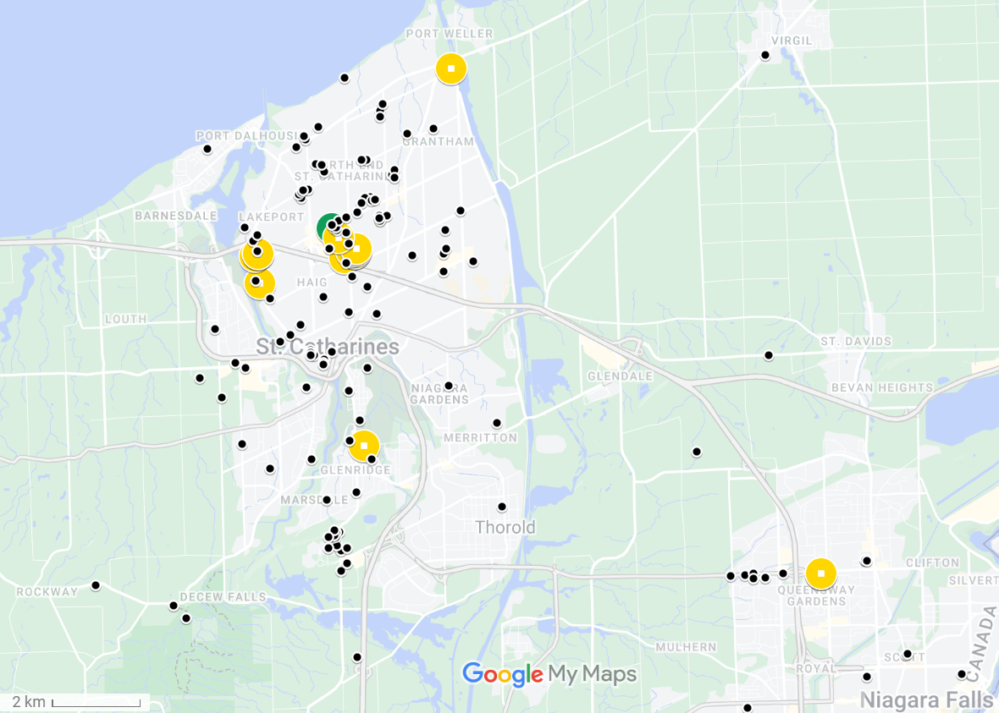

Figure 2: Map of observations from Crowkemon Go and sampling locations.

The black dots represent observations collected from Crowkemon Go, and the circular icons are sampling locations. The single recurrent site used is in green. Opportunistic sampling sites are in yellow. Focal area was limited to the St. Catharines & Niagara region.

and visibly dropped 30g of Cheez-Its, then returned to the camera. If crows were on-site, recording would start immediately, whereas if the crows were absent, a crow-caller would be used for 20 minutes (5s. call per min, 5 mins on, 5 mins off for 20 minutes or until crows appear) to attract them. We began recording when crows arrived and recorded up to a maximum of 20 minutes. The recording was stopped if the crows vacated the area for longer than 5 minutes and we remained in the area for 10 minutes post-departure in case the crows returned. If the crows returned within 5 minutes, we would continue the trial. For opportunistic sampling, we looked for crows using Crowkemon Go as a guide. If we found crows that were already foraging, we would set up in the same manner as for recurrent sampling and did not bait the site. Conversely, if the crows were not already foraging, we would bait the site as we did for recurrent sampling.

The presence of a sentinel, whether heard or seen, was announced verbally by the observer during the recording. For each location, we classified the type of environment using St. Catharines municipal zoning maps, later generalized as either “commercial” or “green” (Table S1**)**. Disturbance frequency was calculated by dividing the number of disturbances by the duration of the recording. We identified disturbances as anything passing within 5m of the crows’ foraging area, including vehicles, pedestrians, domestic and wild animals. Group size was binned into two categories: small (4) and large (4).

Video Analysis

For video analyses, we used the Behavioral Observation Research Interactive Software (BORIS v.8.9.4) [73]. We classified behaviours as either “foraging” or “alert”. “Alert” behaviour was defined as an upright posture where the individual is scanning its surroundings, and “foraging” was when the individual was looking downward and unable to effectively scan their surroundings while pecking at or looking for food on the ground (Table S2). We recorded the duration of bouts of each behaviour longer than 0.01s. Movement behaviour was recorded, but since not all bouts of movement were recorded in their entirety, “moving” behaviour was excluded from these analyses. We then calculated the proportion of time spent performing each behaviour. An individual could have two observations if sentinel presence changed, as bouts were recorded separately for if a sentinel was present or not.

We also recorded the number of pecks (handling food with their beaks for the purpose of eating it) to quantify foraging effort. The peck rate (per min) was calculated for every individual by dividing the total number of pecks at food performed by the total duration of “foraging” behaviour. The peck rate of individuals that spent no time foraging could not be calculated and were therefore excluded from peck rate analysis.

Statistical Analysis

All statistical analyses were performed in the R environment (v.4.2.2; R Core Team 2022) [74]. We first ran separate chi-squared tests to determine if the generalized environment, the group size, or the disturbance frequency affected the likelihood of sentinel presence. To determine the effects of generalized environment and sentinel presence on the proportion of time allocated to each behaviour (alert or foraging), we used the “lm” function in the R Stats package [74] to fit a linear model using behaviour type, sentinel presence, and generalized environment as predictors.

To determine the effects of generalized environment and the presence of a sentinel on the duration of bouts of all behaviours, we used the function “rlmer” from the “robustlmm” package [75] to fit a robust linear mixed model to the log-transformed duration of bouts with behaviour type, sentinel presence, generalized environment, group size, and bait presence as fixed factors, the disturbance frequency (number of disturbances per min.) as a fixed effect and the individual ID as a random effect. We then fitted post-hoc robust linear mixed models on each behaviour to determine the effects of sentinel presence and generalized environment on each behaviour. The duration of behavioural bouts was log-transformed to normalize the distribution.

To determine the effects of sentinel presence and generalized environment on peck rate, we used the function “rlmer” from the “robustlmm” package [75] to fit a robust linear mixed model to the peck rate of foragers using sentinel presence, generalized environment, group size, and bait presence as fixed factors, the disturbance frequency (per min) as a fixed effect, and the individual ID as a random effect.

Finally, we counted the number of transitions from each behaviour to determine the effects of sentinel presence and generalized environment on the frequency of each transition type. Using the “glmer” function from the “lme4” package [76], we fitted a generalized linear mixed model using a Poisson distribution to the number of occurrences of each transition. Sentinel presence, generalized environment, and bait presence were fixed factors, the disturbance frequency (per min) was used as a fixed effect, and the total number of transitions performed by the individual was used as a random effect in the model.

Post hoc estimated marginal means tests were performed as appropriate using the “emmeans” function from the “emmeans” package [77]. P-values were corrected using the “fdr” method, and the results were averaged over the unused categorical factors.

Results

Sentinel presence

In summer 2022, we recorded 23 videos of crows foraging and made 13 observations in commercial and 20 observations in green areas. Since sentinel presence changed in 8 videos, we made 19 observations with a sentinel present and 14 observations without a sentinel for a total of 33 observations. The generalized environment (χ2 = 0.122, df = 1, p = 0.727; Figure S2), group size (χ2 = 0.248, df = 1, p = 0.618; Figure S3), and the disturbance frequency (χ2 = 2.033, df = 2, p = 0.362; Figure S3) did not significantly affect if a sentinel was present or not in our observations.

Proportion of time allocated to each behaviour

We recorded 64 individuals across 23 videos. Since 17 individuals were recorded in both the presence and absence of a sentinel, we calculated the proportion of time allocated to each behaviour for 81 observations. Crows allocated similar proportions of time to foraging and vigilance ( = 0.026, SE = 0.023, t = 1.160, p = 0.248; Figure 3, Table 4), and neither the presence of a sentinel ( = -0.034, SE = 0.023, t = -1.431, p = 0.154; Figure 3, Table 4) or the generalized environment ( = 0.034, SE = 0.023, t = 1.463, p = 0.146; Figure 3, Table 4) had an effect on the proportion of time allocated to either alert or foraging behaviour.

.

Figure 3: Proportion of time allocated to each behaviour by foragers in commercial and green areas

Table 4: Effects of sentinel presence and generalized environment on the proportion of time allocated to each behaviour

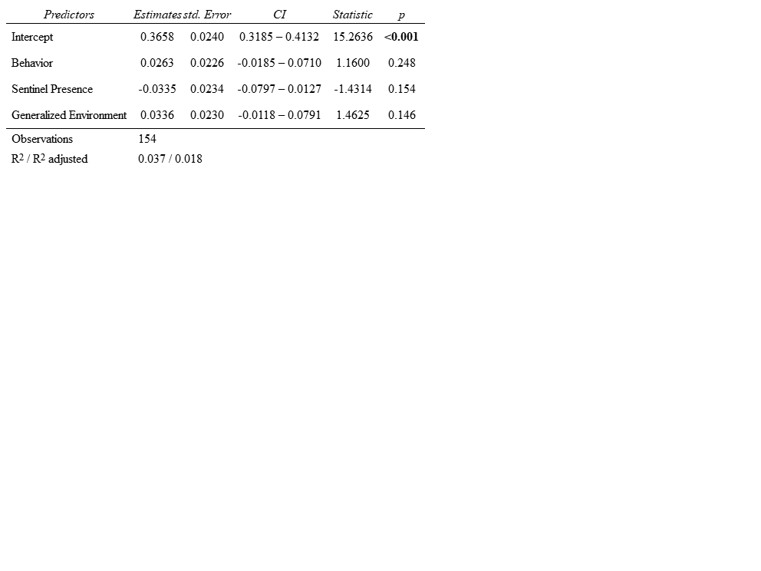

Duration of bouts of all behaviours

In total, 3897 bouts were recorded, of which 2110 bouts were of “alert” behaviour, 1787 bouts were of “foraging” behaviour. The average duration of bouts was of 1.75 seconds. Bouts of alertness and foraging significantly differed ( = -0.256, SE = 0.051, t = -5.002, p = <0.001; Figure 4, Table 5), with bouts of alertness significantly (1.64 seconds) shorter than bouts of foraging (1.88 seconds). Sentinel presence significantly increased the duration of bouts of all behaviours( = 0.197, SE = 0.072, t = 2.741, p = 0.006; Figure 4, Table 5). Green areas saw significantly longer bouts of all behaviours than commercial areas ( = 0.353, SE = 0.087, t = 4.048, p = <0.001; Figure 4, Table 5). Disturbance frequency had a significant effect on the duration of all bouts ( = -0.088, SE = 0.030, t = -2.975, p = 0.003; Figure S4, Table 5), with bout duration decreasing as disturbance frequency increased. We found a significant interaction between generalized environment and sentinel presence ( = -0.252, SE = 0.088, t = -2.863, p = 0.004; Figure 4, Table 5), and between behaviour type and generalized environment ( = -0.202, SE = 0.054, t = -3.769, p = <0.001; Figure 4, Table 5).

Duration of bouts of “foraging” behaviour

To determine if the generalized environment and sentinel presence affected the duration of bouts of foraging and alert behaviour differently, we fit separate linear mixed models for each type of behaviour bout. Sentinel presence had no significant effect on the duration of bouts of foraging behaviour ( = 0.092, SE = 0.072, t = 1.280, p = 0.201; Figure 4, Table 5). Generalized environment had a significant effect on the duration of bouts of foraging behaviour, with longer bouts in green areas ( = 0.383, SE = 0.078, t = 4.919, p = <0.001; Figure 4, Table 5). Larger groups had significantly longer bouts of foraging behaviour ( = -0.152, SE = 0.068, t = -2.221,

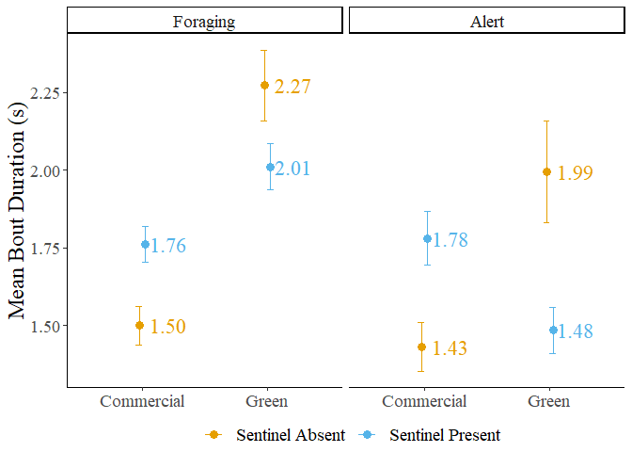

Figure 4: Mean bout duration of foragers in commercial and green areas. The error bars represent the standard error.

Table 5: Results of the linear mixed models fit to the mean bout duration

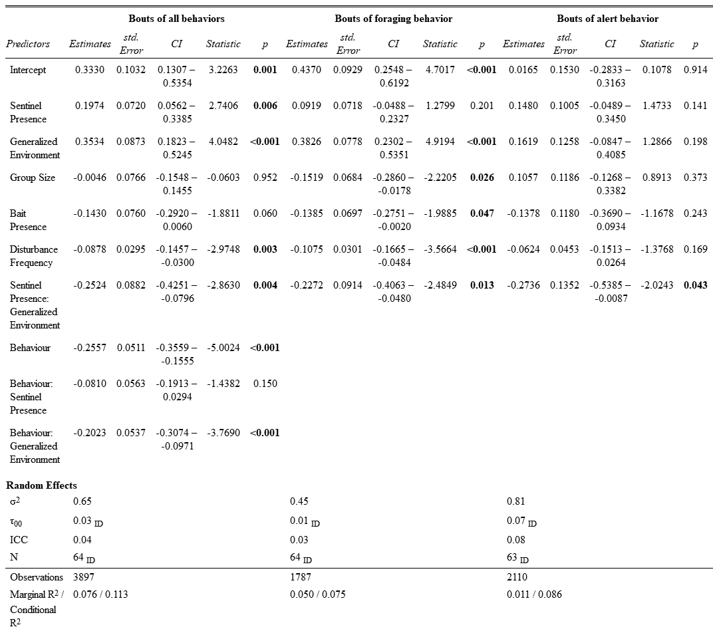

p = 0.026; Figure 5, Table 5). The presence of bait significantly decreased the duration of foraging bouts ( = -0.139, SE = 0.070, t = -1.989, p = 0.047; Figure S5, Table 5). Increasing disturbance frequency significantly decreased the duration of foraging bouts ( = -0.108, SE = 0.030, t = -3.566, p = <0.001; Figure 6, Table 5). We found a significant interaction between generalized environment and sentinel presence ( = -0.227, SE = 0.091, t = -2.485, p = 0.013; Figure 4, Table 5). Post hoc tests revealed significant differences in the duration of bouts of foraging behaviour. In the absence of a sentinel, foragers in green areas had significantly longer bouts of foraging behaviour than in commercial areas ( = -0.383, SE = 0.078, z-ratio = -4.919, p < 0.001; Table S3). In the presence of a sentinel, foragers in green areas also had significantly longer bouts of foraging behaviour than in commercial areas ( = -0.156, SE = 0.067, z-ratio = -2.337, p = 0.029; Table S3). In green areas, foragers in the presence of a sentinel had marginally shorter bouts of foraging behaviour than in the absence of a sentinel ( = 0.135, SE = 0.068, z-ratio = 1.977, p = 0.058; Table S3).

Duration of bouts of “alert” behaviour

Sentinel behaviour, generalized environment, group size, bait presence and disturbance frequency had no significant effect on the duration of bouts of alert behaviour (p < 0.141; Table 5). We found a significant interaction between sentinel behaviour and generalized environment ( = -0.274, SE = 0.135, t = -2.024, p = 0.043; Figure 4, Table 5). Post hoc pairwise t-tests revealed no significant differences in the duration of bouts of alert behaviour.

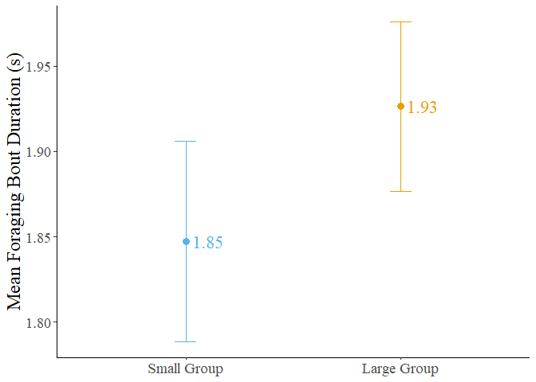

Figure 5: Mean foraging bout duration of crows in small and large groups. Error bars represent the standard error.

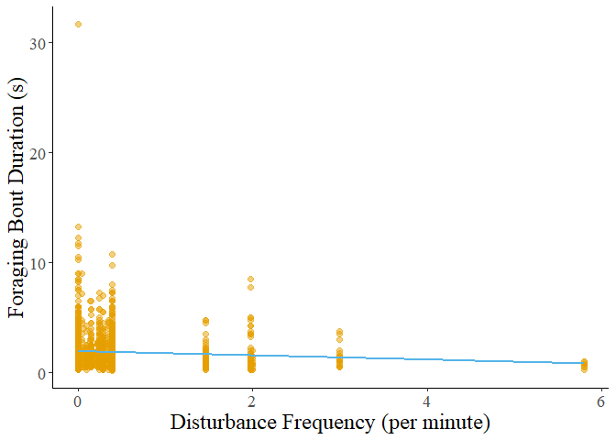

Figure 6: Foraging bout duration decreasing with increasing disturbance frequency.

Foraging rate

We calculated the peck rate (per min.) for 81 observations. Two observations were removed as the individuals did not perform any foraging behaviour. Neither the presence of a sentinel, the generalized environment, or group size had a significant effect on the peck rate of foragers (p > 0.233; Figure 7, Table 6). The presence of bait significantly increased the peck rate of foragers ( = 13.990, t = 2.231, p = 0.020; Figure S6, Table 6). Peck rate increased significantly with disturbance frequency ( = 5.290, t = 2.312, p = 0.021; Figure 8, Table 6). We found a significant interaction between generalized environment and disturbance frequency ( = 16.150, t = 3.046, p = 0.002; Figure 8, Table 6).

Transition analysis

The number of transitions from foraging to alert behaviour was significantly higher in green areas (IRR = 0.421, SE = 0.157, z = -1.355, p = 0.020; Figure 9, Table 7), and in areas with frequent disturbances (IRR = 0.728, SE = 0.109, z = -2.130, p = 0.033; Figure 10, Table 7). We found a significant interaction between generalized environment and sentinel presence (IRR = 5.021, SE = 2.457, z = 3.298, p = 0.001; Figure 9, Table 7). The number of transitions from foraging to pecking was significantly higher in the presence of bait (IRR = 1.710, SE = 0.384, z = 2.386, p = 0.017; Figure S7, Table 7). Sentinel presence, generalized environment, disturbance frequency, or the interaction between sentinel presence and generalized environment did not affect the number of transitions from foraging to pecking (p-value > 0.385; Table 7). The number of transitions from pecking to alert behaviour was also significantly higher in the presence of bait (IRR = 2.204, SE = 0.538, z = 3.238, p = 0.001; Figure S7, Table 7). Sentinel presence, generalized environment, disturbance frequency, or the interaction between sentinel presence and generalized environment did not affect the number of transitions from pecking to alert behaviour

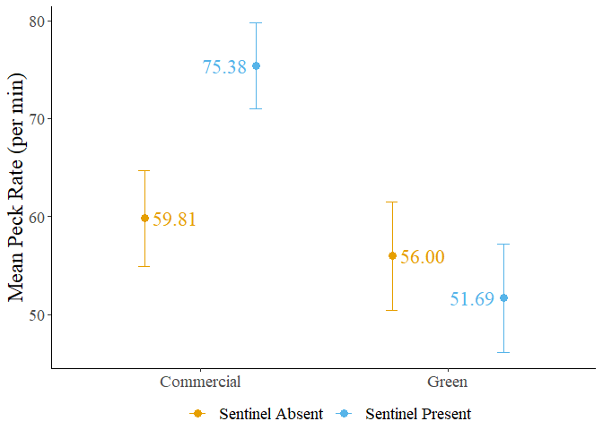

Figure 7: Mean peck rate of foragers in commercial and green areas. Error bars represent the standard error.

Table 6: Result of the linear mixed model fit to peck rate

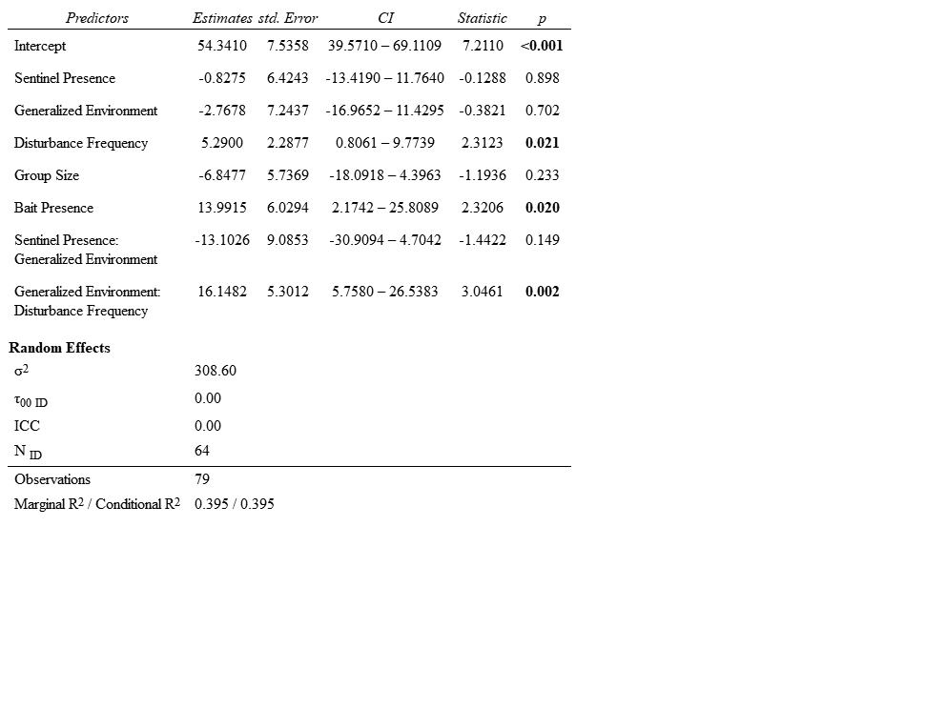

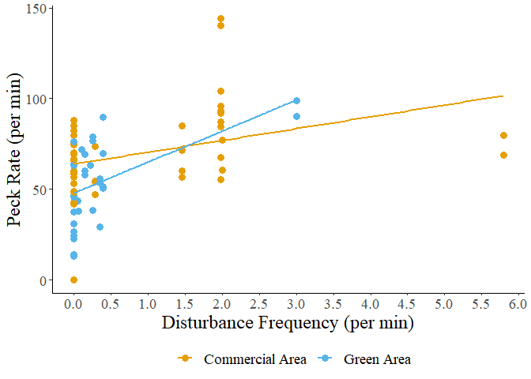

Figure 8: Peck rate in relation to disturbance frequency.

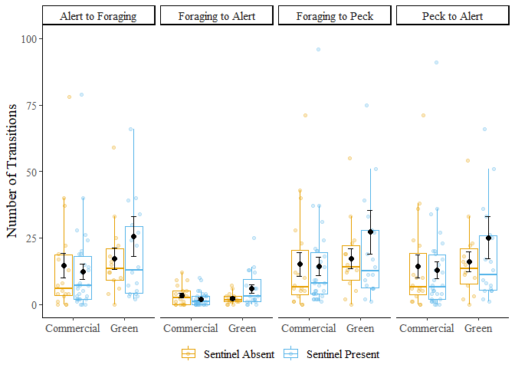

Figure 9: Number of transitions performed by foragers in commercial and green areas. Error bars represent the standard error. Three outliers (Nb.>100) omitted from figure.

Table 7: Results of generalized linear mixed model fit to the number of transitions performed by foragers

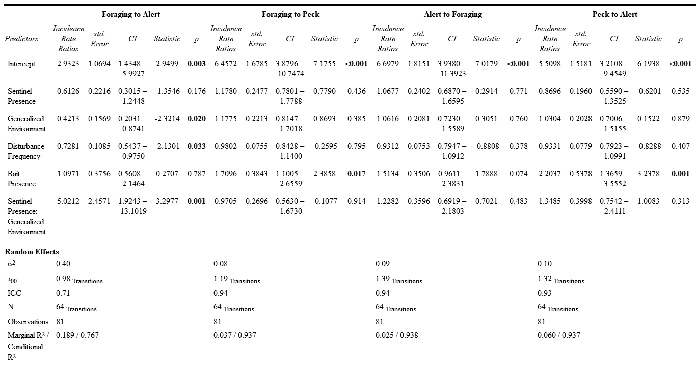

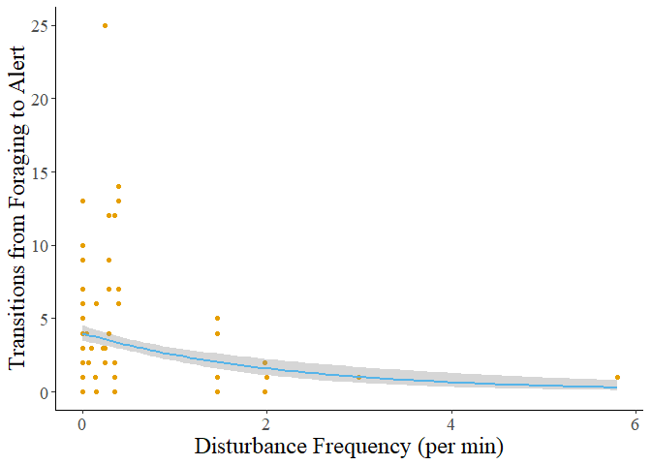

Figure 10: The number of transitions from foraging to alert behaviour decreases as disturbance frequency increases. The grey shadow represents the standard error of the curve.

(p-value > 0.235; Table 7). The number of transitions from alert to foraging behaviour were not significantly affected by any factors, however, bait presence had a marginally insignificant effect (IRR = 1.513, SE = 0.351, z = 1.789, p = 0.074; Figure S7, Table 7).

Post hoc testing on the number of transitions from foraging to alert behaviour revealed that in green areas, individuals performed more transitions from foraging to alert when in the presence of a sentinel ( = -1.124, SE = 0.346, z-ratio = -3.250, p = 0.007; Table S4). Foragers in the presence of a sentinel performed marginally more transitions from foraging to alert in green areas than in commercial areas ( = -0.749, SE = 0.364, z-ratio = -2.062, p = 0.079; Table S4). However, foragers in the absence of a sentinel performed marginally more transitions from foraging to alert behaviour in commercial areas than in green areas ( = 0.864, SE = 0.372, z-ratio = 2.321, p = 0.061; Table S4).

Discussion

Our study sought to investigate how the presence of a sentinel and the generalized environment affected the behavior of foraging American crows. We initially hypothesized that the presence of a sentinel would decrease the individual vigilance of crow foragers, and that green areas would likewise decrease individual vigilance due to reduced ambient noise and longer lines of sight. We also expected the likelihood of a sentinel being present to increase in commercial and frequently disturbed areas where the benefits of sentinel coverage would be most beneficial to the foragers. Sentinel presence had no other significant effects on the behaviour of foragers apart from significantly increasing the duration of all behaviours. Moreover, neither the generalized environment, disturbance frequency, nor group size significantly affected the likelihood of a sentinel being present. This unexpected result suggests that sentinel crows could decide to perform sentinel behavior based more on selfish needs rather than the benefits imparted to the foragers. We found that the generalized environment had a significant effect on forager behavior, with green areas leading to longer bouts of foraging behavior and more transitions from the vulnerable to the alert state. This suggests that crows could perceive green areas as less safe, possibly because they need to spend more time being vulnerable. Overall, the study's findings do not fully support the initial hypotheses and suggest that sentinel behavior and forager behavior in crows could be influenced by complex interactions between individual factors and forager’s perception of the safety of their environment.

Sentinel behaviour

Our results contrast with previous studies that found that the presence of a sentinel led to a decrease in alert behavior [39,60]. For example, pied babblers, *Turdoides bicolor*, increased the proportion of time spent foraging after the start of a sentinel bout and had increased biomass intake. Sentinel behavior can be more selfish in nature, primarily benefiting the sentinel itself rather than being an altruistic strategy benefiting the group at the expense of the sentinel. Bedneckoff's state-dependent model states that individuals make decisions based on their own energetic needs and the benefits they receive [28]. An individual with sufficient energetic reserves could decide to perform sentinel behaviour as a safer option if the alternative is foraging without a sentinel. In urban areas, where high-calorie food patches are bountiful, individuals could be forgoing foraging to act as sentinels for their own safety rather than to provide benefits to the other foraging group-members. These sentinels only come down when they are below a critical energetic threshold past which performing sentinel behaviour is unfavourable only to be replaced by another individual with sufficient energetic reserves [28,29]. The benefits of sentinel behavior can be more subtle or indirect, such as providing a greater sense of security that allows foragers to focus more on foraging without actively reducing their vigilance. The proportion of time allocated to alert behaviour could also be used to scan for foraging patches and other foragers, explaining the absence of effects of sentinel presence on the proportion of time spent being alert. Foragers could also be benefitting from sentinel presence by increasing the distance between foragers, permitting the group to forage over a greater surface area while compensating for the increased predation risk from foraging further apart [39]. Sentinel behaviour could therefore compensate for riskier group-foraging strategies, not only individual changes in behaviour. The relationship between sentinels and foragers is more complex than it appears, reinforcing the importance of considering individual differences and motivations when studying social behaviors.

Generalized Environment

We found that the generalized environment had significant effects on forager behaviour, particularly in terms of the duration of bouts of foraging behavior and the number of transitions from the vulnerable to the alert state. In green areas, crows exhibited longer bouts of foraging behavior, suggesting that they spent more time actively searching for food. Likewise, an increase in the number of transitions from the vulnerable state to the alert state was observed in green areas, suggesting that crows were more vigilant and alert to potential threats, possibly due to the perceived higher predation risk compared to commercial areas.

Green areas, such as parks, offer longer lines of sight and less ambient noise which makes the sentinel more effective [78] but could also be benefitting urban raptors. Urban red-tailed hawk populations are on the rise and the core of their home ranges were associated with large green areas [67]. Foraging in green areas could therefore be riskier than initially hypothesized, explaining the individual need to maintain vigilance. We observed foraging crows abandon sites when disturbed by raptors but only temporarily flee when disturbed by vehicles. Crows foraging in the street will change lanes to avoid oncoming vehicular traffic [79], suggesting that the type of disturbances in each environment could change how risky an environment is to forage on.

The increased duration of foraging bouts in green areas could suggest that they need to spend more time actively searching for and consuming food. We observed shorter bouts of foraging behavior but a higher peck rate in commercial areas. In green areas, food can be more dispersed, require more time to locate, and could be obscured by vegetation. Comparatively, food scraps and litter in commercial areas which are considerably easier to forage on when on impermeable surfaces. Moreover, anthropogenic foods have a greater caloric content than non-anthropogenic foods, making them easier to find and more satiating than other food sources, likely playing a role in the shift in their foraging preferences for anthropogenic foods [49,50].

We found a significant interaction between sentinel presence and generalized environment on the behaviour of crow foragers. The number of transitions from a vulnerable to alert state was highest in green areas and in the presence (Figure 8). We found a significant interaction between sentinel presence and generalized environment on the duration of bouts of foraging and alert behaviour. Bouts were longest in green areas and in the absence of a sentinel, and shortest in commercial areas and in the absence of a sentinel (Figure 3). Foragers could be using the indirect benefits provided by sentinel behaviour differently based on their individual and group needs. In green areas foragers could be relying more on the sentinel, foraging further apart and not coordinating vigilance with other group-members. We observed this as shorter but more numerous bouts of alert behaviour between longer foraging bouts. In contrast, foragers in the absence of a sentinel could be relying more heavily on social foraging behaviour between foragers on the ground, with longer bouts of alert behaviour to increase the likelihood of at least one crow being alert. Whether crows have ground-level coordination of vigilance is an interesting topic for future research.

In commercial areas, crows in the absence of a sentinel could be foraging in an all-or-nothing manner, devoting as little time as possible to each behaviour resulting in shorter bouts of both foraging and alert behaviour, with a duration similar to the duration of bouts of alert behaviour in green areas and in the presence of a sentinel. In comparison, foragers in the presence of a sentinel and in commercial areas saw approximately equal durations of bouts of foraging and alert behaviour. The increased duration of bouts of alert behaviour could be due to the increased frequency and velocity of disturbances, paired with the increased ambient noise, making the sentinel’s behaviour less effective. The duration of bouts of foraging behaviour was likewise increased but not as much as in green spaces, further supporting the hypothesis that foraging in green spaces requires more handling time than in commercial areas. By changing the duration and frequency of bouts to best take advantage of the benefits provided by the sentinel, crows maximize their foraging success and minimize the risk of predation in different foraging environments. American crows continue to demonstrate a behavioural adaptability that is likely crucial for their success in urban cityscapes, and this adaptability must also include the use of social foraging behaviours.

Disturbances

Higher disturbance frequency led to a decrease in the duration of bouts of all behaviors, particularly foraging. American crows decreased their time foraging to minimize their exposure to perceived threats. Areas with higher disturbance frequencies typically had a greater frequency of vehicular disturbances, which American crows could be more tolerant to. As a result and consistent with the risk allocation hypothesis [80], crows will continue to forage between disturbances, but will also increase foraging rate when under high chronic risk of predation. Peck rate did significantly increase with disturbance frequency, and we found a significant interaction between disturbance frequency and generalized environment on peck rate. In response to increasing disturbance frequency, foragers in green areas increased their peck rate more than foragers in commercial areas, further supporting the hypothesis that the type of disturbance as well as the frequency affects the foraging behaviour of urban crows. Higher disturbance frequency was also associated with a significant decrease in the number of transitions from foraging to alert behaviour, from which we can infer that crows will attempt to spend as little time as possible under threat while maximizing time spent foraging. Crows could then be foraging as quickly as possible while maintaining minimal vigilance and flying away as soon as a threat is detected.

Baited sites

The presence of bait, which can be considered a proxy for human-generated litter in the environment, increased the peck rate and decreased the duration of foraging bouts. This suggests that foraging on bait or litter is more efficient and safer for crows, requiring less time and effort compared to foraging on natural food sources. This observation could explain why a shift in preference for anthropogenic foods is observed in American crows and potentially other urbanized species [49,50]. American crows are increasingly found in North American cities and the increasing abundance of crows in cities is believed to be driven by the increased presence of highly caloric anthropogenic foods [49].

Group Size

As group size increased, the duration of bouts of foraging behaviour increased but was not associated with a decrease in duration of bouts of alert behaviour. The proportion of time allocated to either behaviour was also unchanged by the size of the group. This finding is surprising, as previous studies suggest that larger group sizes should decrease individual vigilance while increasing foraging efficiency [63,81–83], yet the effect of group size was only observed in the duration of bouts of foraging behaviour. Bouts of alert behaviour could have a minimal duration to effectively monitor the surrounding environment for sources of threat. Alternatively, foraging crows could be maintaining vigilance due to increased competition for resources in larger groups. Instead of only looking out for sources of threat, forager could be looking at the behaviour of other group-members in case they found a better patch to forage on.

Future directions and improvements

Our study has several limitations that should be acknowledged. Our sample size could have limited the ability to detect significant effects. As such, caution should be exercised when interpreting the results, and further studies with larger sample sizes are required to make conclusive statements. Future studies should make use of long-term video recorders in areas where crows forage across a wider breadth of urbanization. Additionally, the study focused on the population of crows in St. Catharines Ontario, which could limit the generalizability of our results to other populations or environments. Factors such as local food availability, the number and area of green spaces, and predator presence can vary widely between cities, and these factors can affect the behaviour of murders of foraging crows. Therefore, the findings of our study could differ from those of a similar study performed in a different city, but also within the city. Crows can aggregate in many other areas besides green and commercial areas, and future research could be conducted on the effects of urban microcosms on the social foraging of crows.

Conclusion

Our study investigated the effects of sentinel behavior and the generalized environment on the behavior of foraging crows in urban environments. Contrary to expectations, sentinel presence did not have a significant effect on forager behavior. This suggests that sentinel decision-making could be more influenced by individual needs rather than group benefits, aligning with Bednekoff's state-dependent model. The generalized environment, however, had a significant impact on forager behavior. Crows in green areas exhibited longer bouts of foraging behavior and more transitions from the vulnerable to the alert state compared to those in commercial areas. This indicates that environmental factors such as resource distribution and predation risk play a crucial role in shaping forager behavior. Disturbance frequency, bait presence, and group size also influenced forager behavior. Higher disturbance frequency led to shorter bouts of behavior but increased peck rate, indicating a trade-off between vigilance and foraging efficiency. Bait presence increased peck rate and decreased foraging time, suggesting that foraging on anthropogenic food sources could be more effective for crows.

These findings have several implications for understanding crow behavior. They suggest that crows can adapt their behavior based on environmental conditions and individual needs. The lack of significant effects of sentinel behavior points towards the complexity of social behavior in crows and the importance of considering individual variation in decision-making. Overall, the study provides valuable insights into the factors influencing crow behavior in urban environments and highlights the need for further research to fully understand these complex behaviors.

General Discussion

References

1. Bednekoff PA. 2015 Sentinel behavior: a review and prospectus. In *Advances in the Study of Behavior*, pp. 115–145. Elsevier. (doi:10.1016/bs.asb.2015.02.001)

2. Blumstein DT. 1999 Selfish sentinels. *Science* **284**, 1633–1634. (doi:10.1126/science.284.5420.1633)

3. Huels FD, Stoeger AS. 2022 Sentinel behavior in captive meerkats ( *Suricata suricatta* ). *Zoo Biol.* **41**, 10–19. (doi:10.1002/zoo.21644)

4. Rauber R, Manser MB. 2021 Effect of group size and experience on the ontogeny of sentinel calling behaviour in meerkats. *Anim. Behav.* **171**, 129–138. (doi:10.1016/j.anbehav.2020.11.014)

5. Rauber R, Clutton-Brock TH, Manser MB. 2019 Drought decreases cooperative sentinel behavior and affects vocal coordination in meerkats. *Behav. Ecol.* **30**, 1558–1566. (doi:10.1093/beheco/arz112)

6. Santema P, Clutton-Brock T. 2013 Meerkat helpers increase sentinel behaviour and bipedal vigilance in the presence of pups. *Anim. Behav.* **85**, 655–661. (doi:10.1016/j.anbehav.2012.12.029)

7. Santema P, Teitel Z, Manser M, Bennett N, Clutton-Brock T. 2013 Effects of cortisol administration on cooperative behavior in meerkat helpers. *Behav. Ecol.* **24**, 1122–1127. (doi:10.1093/beheco/art039)

8. Manser M. 2018 Meerkats – identifying cognitive mechanisms underlying meerkat coordination and communication: experimental designs in their natural habitat. In *Field and Laboratory Methods in Animal Cognition* (eds N Bueno-Guerra, F Amici), pp. 286–307. Cambridge University Press. (doi:10.1017/9781108333191.015)

9. Eastcott E, Kern JM, Morris-Drake A, Radford AN. 2020 Intrapopulation variation in the behavioral responses of dwarf mongooses to anthropogenic noise. *Behav. Ecol.* **31**, 680–691. (doi:10.1093/beheco/araa011)

10. Kern JM, Radford AN. 2018 Experimental evidence for delayed contingent cooperation among wild dwarf mongooses. *Proc. Natl. Acad. Sci.* **115**, 6255–6260. (doi:10.1073/pnas.1801000115)

11. Kern JM, Radford AN. 2014 Sentinel dwarf mongooses, *Helogale parvula*, exhibit flexible decision making in relation to predation risk. *Anim. Behav.* **98**, 185–192. (doi:10.1016/j.anbehav.2014.10.012)

12. Kern JM, Radford AN. 2013 Call of duty? Variation in use of the watchman’s song by sentinel dwarf mongooses, *Helogale parvula*. *Anim. Behav.* **85**, 967–975. (doi:10.1016/j.anbehav.2013.02.020)

13. Horrocks JA, Hunte W. 1986 Sentinel behaviour in vervet monkeys: who sees whom first? *Anim. Behav.* **34**, 1566–1568. (doi:10.1016/S0003-3472(86)80226-3)

14. Bolwig N. 1959 A study of the behaviour of the chacma baboon, *Papio ursinus*. *Behaviour* **14**, 136–162. (doi:10.1163/156853959X00054)

15. Bednekoff PA, Woolfenden GE. 2003 Florida scrub-jays ( *Aphelocoma coerulescens* ) are sentinels more when well-fed (even with no kin nearby): sentinel behavior by Florida scrub-jays fed peanuts. *Ethology* **109**, 895–903. (doi:10.1046/j.0179-1613.2003.00926.x)

16. Hailman JP, McGowan KJ, Woolfenden GE. 2010 Role of helpers in the sentinel behaviour of the Florida scrub jay (*Aphelocoma c. coerulescens*). *Ethology* **97**, 119–140. (doi:10.1111/j.1439-0310.1994.tb01034.x)

17. Bednekoff PA, Woolfenden GE. 2006 Florida scrub-jays compensate for the sentinel behavior of flockmates. *Ethology* **112**, 796–800. (doi:10.1111/j.1439-0310.2006.01227.x)

18. Fleischer AL, Bowman R, Woolfenden GE. 2003 Variation in foraging behavior, diet, and time of breeding of Florida scrub-jays in suburban and wildland habitats. *The Condor* **105**, 515–527. (doi:10.1093/condor/105.3.515)

19. McGowan KJ, Woolfenden GE. 1989 A sentinel system in the Florida scrub jay. *Anim. Behav.* **37**, 1000–1006. (doi:10.1016/0003-3472(89)90144-9)

20. Edelaar P, Wright J. 2006 Potential prey make excellent ornithologists: adaptive, flexible responses towards avian predation threat by Arabian babblers *Turdoides squamiceps* living at a migratory hotspot: predation threat flexibility in babblers. *Ibis* **148**, 664–671. (doi:10.1111/j.1474-919X.2006.00567.x)

21. Ostreiher R, Heifetz A. 2017 The sentinel behaviour of Arabian babbler floaters. *R. Soc. Open Sci.* **4**, 160738. (doi:10.1098/rsos.160738)

22. Ostreiher R, Heifetz A. 2019 The sentineling-foraging trade-off in dominant and subordinate arabian babblers. *Ethology* **125**, 98–105. (doi:10.1111/eth.12833)

23. Ostreiher R, Mundry R, Heifetz A. 2021 On the self-regulation of sentinel activity among Arabian babbler groupmates. *Anim. Behav.* **173**, 81–92. (doi:10.1016/j.anbehav.2021.01.002)

24. Wright J, Berg E, De Kort SR, Khazin V, Maklakov AA. 2001 Cooperative sentinel behaviour in the Arabian babbler. *Anim. Behav.* **62**, 973–979. (doi:10.1006/anbe.2001.1838)

25. Wright J, Maklakov AA, Khazin V. 2001 State-dependent sentinels: an experimental study in the Arabian babbler. *Proc. R. Soc. Lond. B Biol. Sci.* **268**, 821–826. (doi:10.1098/rspb.2000.1574)

26. Gaston AJ. 1977 Social behaviour within groups of jungle babblers (*Turdoides striatus*). *Anim. Behav.* **25**, 828–848.

27. Rafay M, Ahmad G, Ruby T, Abdullah M, Rasheed F, Abid M. 2020 Breeding and feeding behaviour of jungle babbler(*Turdiodes striata dumont*, 1923) in agro-ecological zones of district layyah, pakistan. *Pak. J. Zool.* **52**, 1701–1708. (doi:https://dx.doi.org/10.17582/journal.pjz/20170420070416)

28. Bednekoff PA. 1997 Mutualism among safe, selfish sentinels: a dynamic game. *Am. Nat.* **150**, 373–392. (doi:10.1086/286070)

29. Bednekoff PA. 2001 Coordination of safe, selfish sentinels based on mutual benefits. *Ann. Zool. Fenn.* **38**, 5–14.

30. Wright J, Berg E, De Kort SR, Khazin V, Maklakov AA. 2001 Safe selfish sentinels in a cooperative bird: *Safe selfish sentinels*. *J. Anim. Ecol.* **70**, 1070–1079. (doi:10.1046/j.0021-8790.2001.00565.x)

31. Olson RS, Haley PB, Dyer FC, Adami C. 2015 Exploring the evolution of a trade-off between vigilance and foraging in group-living organisms. *R. Soc. Open Sci.* **2**, 150135. (doi:10.1098/rsos.150135)

32. Lima SL, Dill LM. 1990 Behavioral decisions made under the risk of predation: a review and prospectus. *Can. J. Zool.* **68**, 619–640. (doi:10.1139/z90-092)

33. Lima SL. 1998 Stress and decision making under the risk of predation: recent developments from behavioral, reproductive, and ecological perspectives. In *Advances in the Study of Behavior* (eds AP Møller, M Milinski, PJB Slater), pp. 215–290. Academic Press. (doi:10.1016/S0065-3454(08)60366-6)

34. Trivers RL. 1971 The Evolution of Reciprocal Altruism. *Q. Rev. Biol.* **46**, 35–57.

35. Hamilton WD. 1964 The genetical evolution of social behaviour. I. *J. Theor. Biol.* **7**, 1–16. (doi:10.1016/0022-5193(64)90038-4)

36. Clutton-Brock TH, O’Riain MJ, Brotherton PNM, Gaynor D, Kansky R, Griffin AS, Manser M. 1999 Selfish sentinels in cooperative mammals. *Science* **284**, 1640–1644. (doi:10.1126/science.284.5420.1640)

37. Morris-Drake A, Christensen C, Kern JM, Radford AN. 2019 Experimental field evidence that out-group threats influence within-group behavior. *Behav. Ecol.* **30**, 1425–1435. (doi:10.1093/beheco/arz095)

38. Walker L, York J, Young A. 2016 Sexually selected sentinels? Evidence of a role for intrasexual competition in sentinel behavior. *Behav. Ecol.* **27**, 1461–1470. (doi:10.1093/beheco/arw064)

39. Hollén LI, Bell MBV, Radford AN. 2008 Cooperative sentinel calling? Foragers gain increased biomass intake. *Curr. Biol.* **18**, 576–579. (doi:10.1016/j.cub.2008.02.078)

40. Ducatez S, Sayol F, Sol D, Lefebvre L. 2018 Are urban vertebrates city specialists, artificial habitat exploiters, or environmental generalists? *Integr. Comp. Biol.* **58**, 929–938. (doi:10.1093/icb/icy101)

41. Callaghan CT, Major RE, Wilshire JH, Martin JM, Kingsford RT, Cornwell WK. 2019 Generalists are the most urban-tolerant of birds: a phylogenetically controlled analysis of ecological and life history traits using a novel continuous measure of bird responses to urbanization. *Oikos* **128**, 845–858. (doi:10.1111/oik.06158)

42. UN Department of Economic and Social Affairs. 2018 68% of the world population projected to live in urban areas by 2050, says UN. *U. N.* See https://www.un.org/development/desa/en/news/population/2018-revision-of-world-urbanization-prospects.html.

43. Isaksson C. 2018 Impact of urbanization on birds. In *Bird Species: How They Arise, Modify and Vanish* (ed DT Tietze), pp. 235–257. Cham: Springer International Publishing. (doi:10.1007/978-3-319-91689-7_13)

44. Marzluff JM. 2001 Worldwide urbanization and its effects on birds. In *Avian Ecology and Conservation in an Urbanizing World* (eds JM Marzluff, R Bowman, R Donnelly), pp. 19–47. Boston, MA: Springer US. (doi:10.1007/978-1-4615-1531-9_2)

45. Aronson MFJ *et al.* 2014 A global analysis of the impacts of urbanization on bird and plant diversity reveals key anthropogenic drivers. *Proc. R. Soc. B Biol. Sci.* **281**, 20133330. (doi:10.1098/rspb.2013.3330)

46. Meillère A, Brischoux F, Parenteau C, Angelier F. 2015 Influence of urbanization on body size, condition, and physiology in an urban exploiter: a multi-component approach. *PLOS ONE* **10**, e0135685. (doi:10.1371/journal.pone.0135685)

47. Lowry H, Lill A, Wong BBM. 2013 Behavioural responses of wildlife to urban environments. *Biol. Rev. Camb. Philos. Soc.* **88**, 537–549. (doi:10.1111/brv.12012)

48. Francis RA, Chadwick MA. 2012 What makes a species synurbic? *Appl. Geogr.* **32**, 514–521. (doi:10.1016/j.apgeog.2011.06.013)

49. Marzluff JM, McGowan KJ, Donnelly R, Knight RL. 2001 Causes and consequences of expanding American Crow populations. In *Avian Ecology and Conservation in an Urbanizing World* (eds JM Marzluff, R Bowman, R Donnelly), pp. 331–363. Boston, MA: Springer US. (doi:10.1007/978-1-4615-1531-9_16)

50. Marzluff JM, Neatherlin E. 2006 Corvid response to human settlements and campgrounds: Causes, consequences, and challenges for conservation. *Biol. Conserv.* **130**, 301–314. (doi:10.1016/j.biocon.2005.12.026)

51. Withey JC, Marzluff JM. 2009 Multi-scale use of lands providing anthropogenic resources by American Crows in an urbanizing landscape. *Landsc. Ecol.* **24**, 281–293. (doi:10.1007/s10980-008-9305-9)

52. Withey J, Marzluff J. 2005 Dispersal by juvenile American crows influences population dynamics across a gradient of urbanization. *The Auk* **122**, 205–221. (doi:10.1093/auk/122.1.205)

53. De León LF, Sharpe DMT, Gotanda KM, Raeymaekers JAM, Chaves JA, Hendry AP, Podos J. 2019 Urbanization erodes niche segregation in Darwin’s finches. *Evol. Appl.* **12**, 1329–1343. (doi:10.1111/eva.12721)

54. Gotanda KM. 2020 Human influences on antipredator behaviour in Darwin’s finches. *J. Anim. Ecol.* **89**, 614–622. (doi:10.1111/1365-2656.13127)

55. Kern JM, Radford AN. 2016 Anthropogenic noise disrupts use of vocal information about predation risk. *Environ. Pollut. Barking Essex 1987* **218**, 988–995. (doi:10.1016/j.envpol.2016.08.049)

56. Stofberg M, Cunningham S, Sumasgutner P, Amar A. 2019 Juggling a “junk-food” diet: responses of an urban bird to fluctuating anthropogenic-food availability. *Urban Ecosyst.* **22**, 1019–1026. (doi:https://doi.org/10.1007/s11252-019-00885-3)

57. Schulte-Hostedde AI, Mazal Z, Jardine CM, Gagnon J. 2018 Enhanced access to anthropogenic food waste is related to hyperglycemia in raccoons (*Procyon lotor*). *Conserv. Physiol.* **6**.

58. Maccarone AD. 1987 Sentinel behaviour in American crows. *Bird Behav.* **7**, 93–95. (doi:10.3727/015613887791918105)

59. Haddaway NR, Macura B, Whaley P, Pullin AS. 2018 ROSES RepOrting standards for Systematic Evidence Syntheses: pro forma, flow-diagram and descriptive summary of the plan and conduct of environmental systematic reviews and systematic maps. *Environ. Evid.* **7**, 7. (doi:10.1186/s13750-018-0121-7)

60. Ridley AR, Wiley EM, Thompson AM. 2014 The ecological benefits of interceptive eavesdropping. *Funct. Ecol.* **28**, 197–205. (doi:10.1111/1365-2435.12153)

61. Kung JY. 2023 Elicit. *J. Can. Health Libr. Assoc.* **44**, 15–18. (doi:10.29173/jchla29657)

62. Lajeunesse MJ. 2015 Facilitating systematic reviews, data extraction and meta‐analysis with the metagear package for r. *Methods Ecol. Evol.* **7**, 323–330. (doi:https://doi.org/10.1111/2041-210X.12472)

63. Lima SL. 1995 Back to the basics of anti-predatory vigilance: the group-size effect. *Anim. Behav.* **49**, 11–20. (doi:10.1016/0003-3472(95)80149-9)

64. Latta SC, Latta KN. 2015 Do urban american crows (*Corvus brachyrhynchos*) contribute to population declines of the common nighthawk (*Chordeiles minor*)? *Wilson J. Ornithol.* **127**, 528–533. (doi:10.1676/14-181.1)

65. Rosenberg KV *et al.* 2019 Decline of the North American avifauna. *Science* **366**, 120–124. (doi:10.1126/science.aaw1313)

66. Johnson R. 1994 AMERICAN CROWS. *Handb. Prev. Control Wildl. Damage*

67. Morrison JL, Gottlieb IGW, Pias KE. 2016 Spatial distribution and the value of green spaces for urban red-tailed hawks. *Urban Ecosyst.* **19**, 1373–1388. (doi:10.1007/s11252-016-0554-0)

68. Ridley AR, Raihani NJ, Bell MBV. 2010 Experimental evidence that sentinel behaviour is affected by risk. *Biol. Lett.* **6**, 445–448. (doi:10.1098/rsbl.2010.0023)

69. Łopucki R, Klich D, Kiersztyn A. 2021 Changes in the social behavior of urban animals: more aggression or tolerance? *Mamm. Biol.* **101**, 1–10. (doi:10.1007/s42991-020-00075-1)

70. Auman HJ, Meathrel CE, Richardson A. 2008 Supersize Me: Does Anthropogenic Food Change the Body Condition of Silver Gulls? A Comparison Between Urbanized and Remote, Non-urbanized Areas. In *Waterbirds*, pp. 122–126. (doi:10.1675/1524-4695(2008)31[122:SMDAFC]2.0.CO;2)

71. Jones TB, Evans JC, Morand-Ferron J. 2019 Urbanization and the temporal patterns of social networks and group foraging behaviors. *Ecol. Evol.* **9**, 4589–4602. (doi:10.1002/ece3.5060)

72. Møller AP. 1990 Changes in the size of avian breeding territories in relation to the nesting cycle. *Anim. Behav.* **40**, 1070–1079. (doi:10.1016/S0003-3472(05)80173-3)

73. Friard O, Gamba M. 2016 BORIS: a free, versatile open-source event-logging software for video/audio coding and live observations. *Methods Ecol. Evol.* **7**, 1325–1330. (doi:10.1111/2041-210X.12584)

74. R Core Team. 2022 R: the R project for statistical computing.

75. Koller M. 2016 Robustlmm: an R package for robust estimation of linear mixed-effects models. *J. Stat. Softw.* **75**, 1–24. (doi:10.18637/jss.v075.i06)

76. Bates D, Mächler M, Bolker B, Walker S. 2015 Fitting linear mixed-effects models using lme4. *J. Stat. Softw.* **67**, 1–48. (doi:10.18637/jss.v067.i01)

77. Lenth RW. 2023 Emmeans: estimated marginal means, aka least-squares means.

78. Hollén LI, Bell MBV, Wade HM, Rose R, Russell A, Niven F, Ridley AR, Radford AN. 2011 Ecological conditions influence sentinel decisions. *Anim. Behav.* **82**, 1435–1441. (doi:10.1016/j.anbehav.2011.09.028)

79. Mukherjee S, Ray-Mukherjee J, Sarabia R. 2013 Behaviour of American Crows (Corvus brachyrhynchos) when encountering an oncoming vehicle. *Can. Field-Nat.* **127**, 229. (doi:10.22621/cfn.v127i3.1488)

80. Lima SL, Bednekoff PA. 1999 Temporal Variation in Danger Drives Antipredator Behavior: The Predation Risk Allocation Hypothesis. *Am. Nat.* **153**, 649–659. (doi:10.1086/303202)

81. Beauchamp G. 2013 *Social predation: how group living benefits predators and prey*. Elsevier.

82. Beauchamp G. 2008 What is the magnitude of the group-size effect on vigilance? *Behav. Ecol.* **19**, 1361–1368. (doi:10.1093/beheco/arn096)

83. Ward C, Low BS. 1997 Predictors of Vigilance for American Crows Foraging in an Urban Environment. *Wilson Bull.* **109**, 481–489.

Supplemental Material

List of Supplemental Tables

Table S1: Explanation of generalized environment. 64

Table S2: Ethogram of behaviours analyzed during foraging events. 65

Table S3: Results of post hoc tests on foraging bout duration. 69

Table S4: Result of post hoc test performed on the number of transitions from foraging to alert behaviour. 73

List of Supplemental Figures

Figure S1: Number of articles with coordination as a defining feature of sentinel behaviour across time 63

Figure S2: Sentinel presence in commercial and green areas.. 66

Figure S3: Frequency plots of observations in the presence and absence of a sentinel. 67

Figure S4: Decreasing bout duration of all behaviours in response to increasing disturbance frequency. 68

Figure S5: Mean bout duration in the presence and absence of bait. The dots represent the mean value, and the error bars represent the standard error. 70

Figure S6: Mean forager peck rate in the presence and absence of bait. The dots represent the mean value, and the error bars represent the standard error. 71

Figure S7: Number of transitions performed by foragers in the presence and absence of bait. The dots represent the mean value, and the error bars represent the standard error. 72

Number of articles

Coordination as defining feature of sentinel behaviour

Figure S1: Number of articles with coordination as a defining feature of sentinel behaviour across time

Table S1: Explanation of generalized environment.

|  |  |
| --- | --- |
| Generalized Environment | Zones included |
| Commercial Area | Arterial Commercial, Business Commercial Employment, Community Commercial, Major Commercial |
| Green Area | Major Green Space, Minor Green Space |

Each zone type was identified using the St. Catharines and Niagara zoning maps for each sampling location.

Table S2: Ethogram of behaviours analyzed during foraging events.

|  |  |  |  |
| --- | --- | --- | --- |
| Behaviour | Code | Definition | Illustration |
| Foraging | Head Down | Focal individual is stationary and has its head downwards or in a non-upright position, either pecking or handling food, looking for food, or engaging in other behaviours that make vigilance ineffective (e.g. preening). |  |
| Moving | Moving | Focal individual is moving, either by flying, hopping (leaping), or walking. |  |
| Alert | Head Up | The focal individual is stationary and has its head and body in an upright position. Individuals can have a mobile (scanning) or immobile head but must not be looking downwards. Individuals can be handling food. |  |

*All illustrations are under creative commons license (copyright-free)*

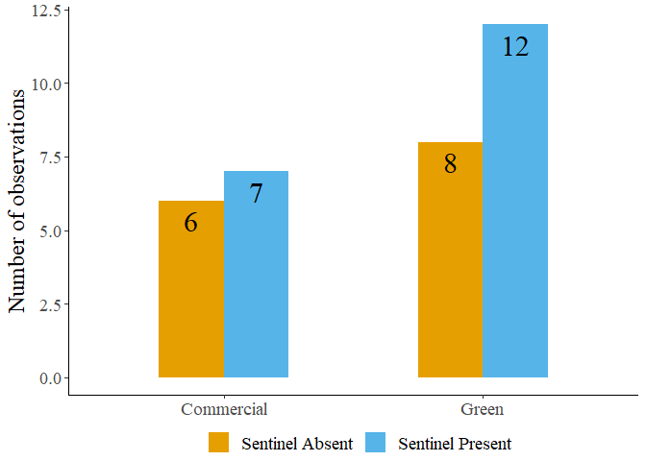

Figure S2: Sentinel presence in commercial and green areas..

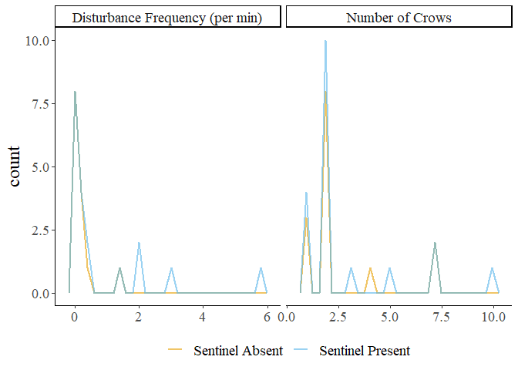

Figure S3: Frequency plots of observations in the presence and absence of a sentinel.

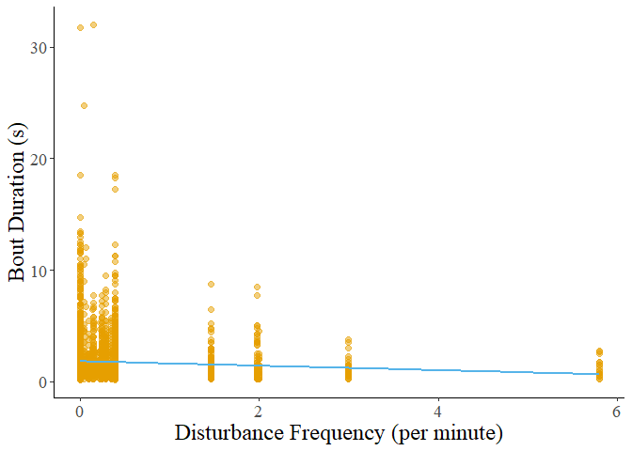

Figure S4: Decreasing bout duration of all behaviours in response to increasing disturbance frequency.

Table S3: Results of post hoc tests on foraging bout duration.

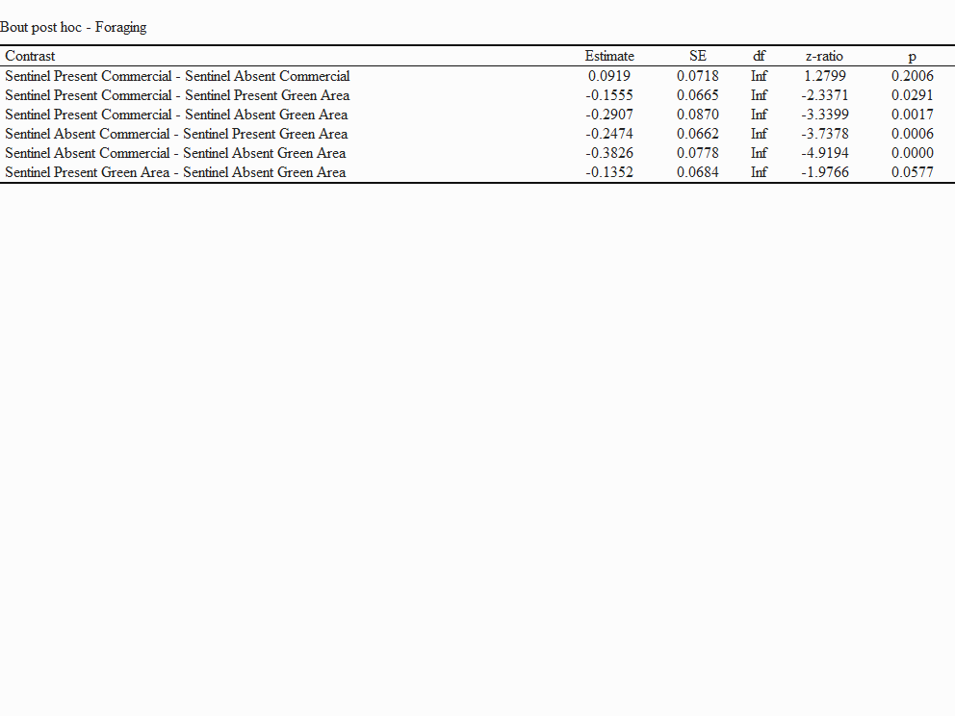

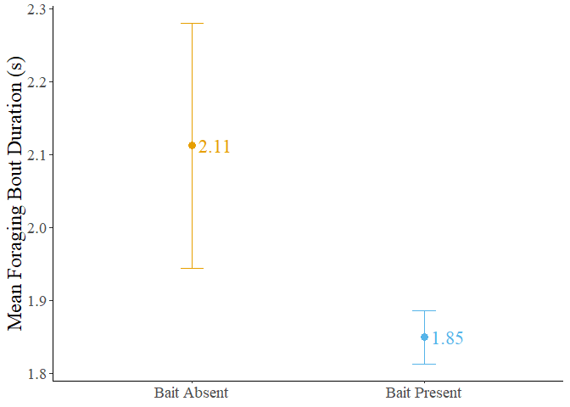

Figure S5: Mean bout duration in the presence and absence of bait. The dots represent the mean value, and the error bars represent the standard error.

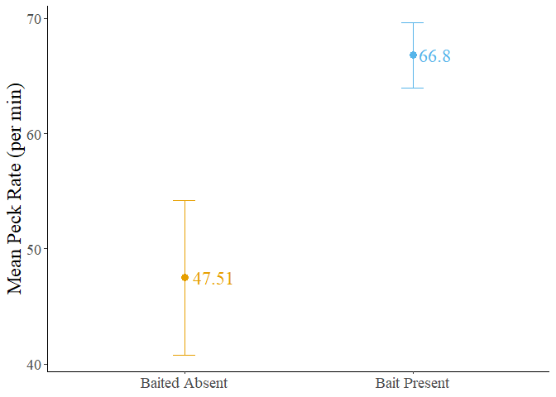

Figure S6: Mean forager peck rate in the presence and absence of bait. The dots represent the mean value, and the error bars represent the standard error.

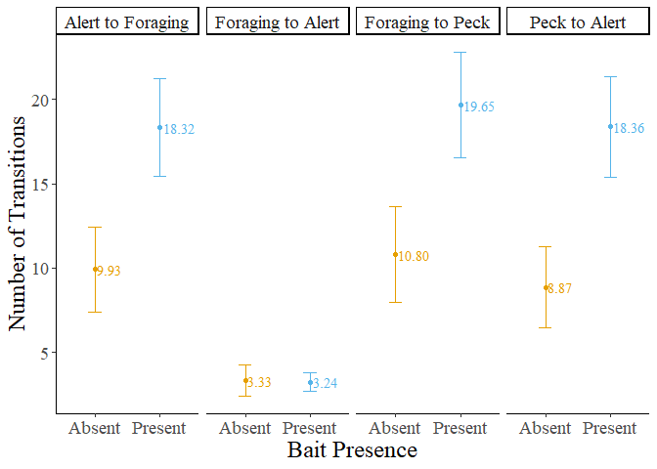

Figure S7: Number of transitions performed by foragers in the presence and absence of bait. The dots represent the mean value, and the error bars represent the standard error.

Table S4: Result of post hoc test performed on the number of transitions from foraging to alert behaviour.

